**PHP Internship Report**

**Personal Details**

Name : Adit Vyas

College Name : Sardar Patel College of Engineering Bakrol

Degree : BE

Semester : 7

Github URL : [https://github.com/ Adit-Vyas](https://github.com/%20Adit-Vyas)

**Company Details**

Company Name : Akash Technolabs

External Guide : Akash Padhiyar

Training Duration : 26-05-2021 to 21-06-2021

**Index**

|  |  |  |
| --- | --- | --- |
| **Index** | **Task Detail** | **Page Name** |
| 1 | Hello World | 1 |
| 2 | Factorial | 2 |
| 3 | Website Home Page | 3 |
| 4 | Website Facilities | 9 |
| 5 | Website Faculties | 11 |
| 6 | Time Table | 17 |
| 7 | Loop | 23 |
| 8 | Palindrome | 25 |
| 9 | MinMax | 27 |
| 10 | Get/Post | 29 |
| 11 | Associative Array | 31 |
| 12 | Numeric Array | 33 |
| 13 | Leap Year | 35 |
| 14 | Odd Even | 37 |
| 15 | Subtraction | 39 |

**1. Hello World Code**

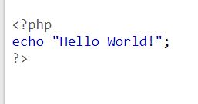

**Output**



**2. Factorial Code**

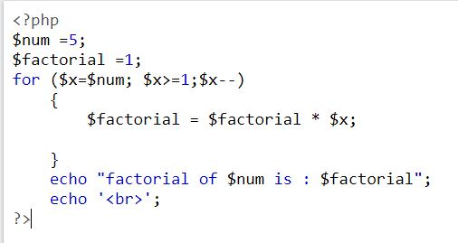

**Output**



**3. Website Home Page**

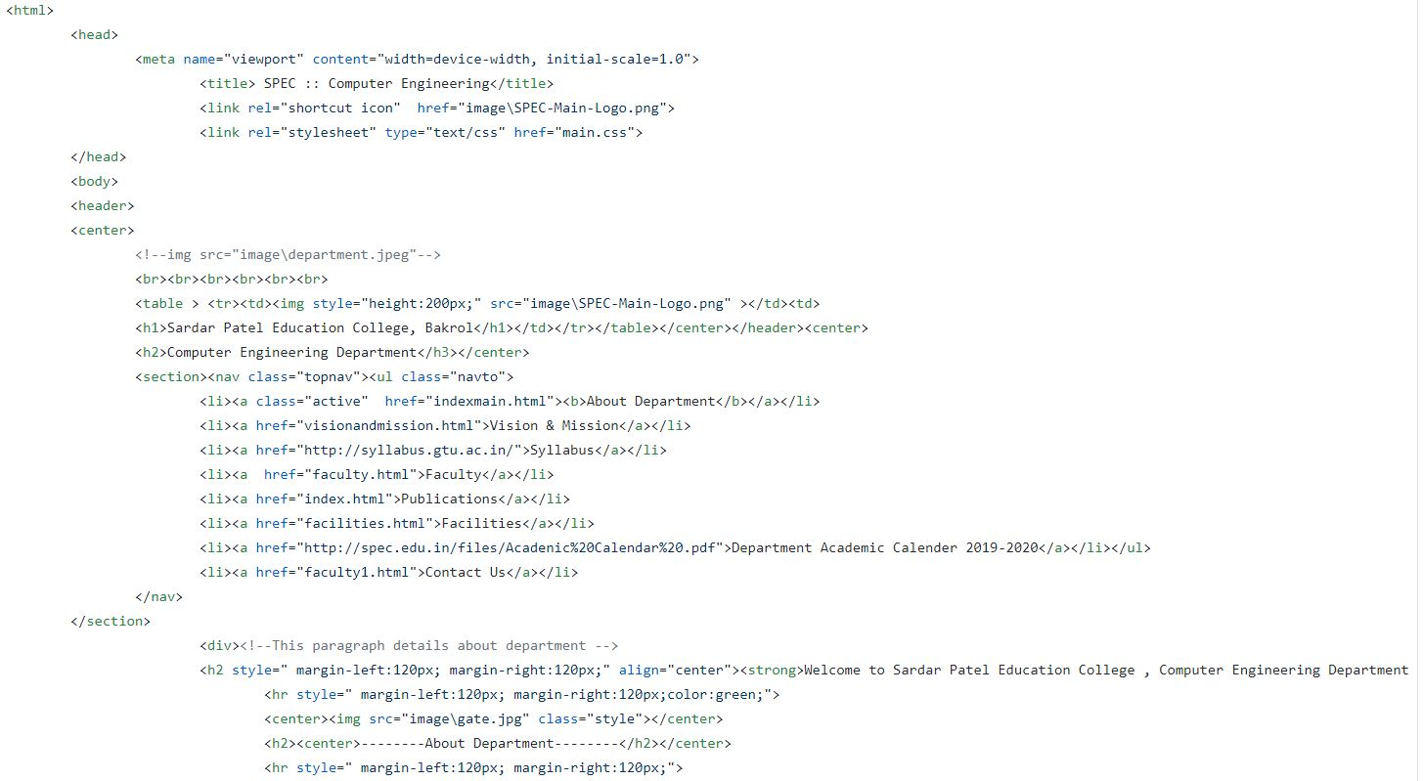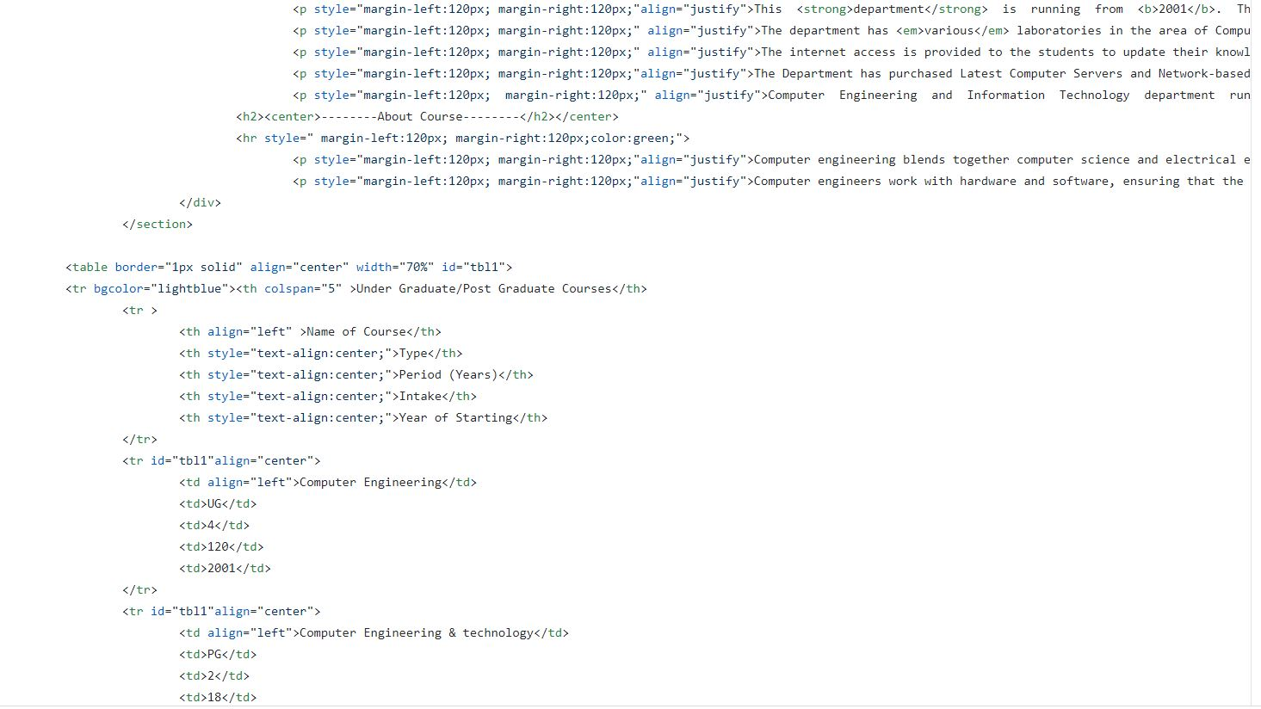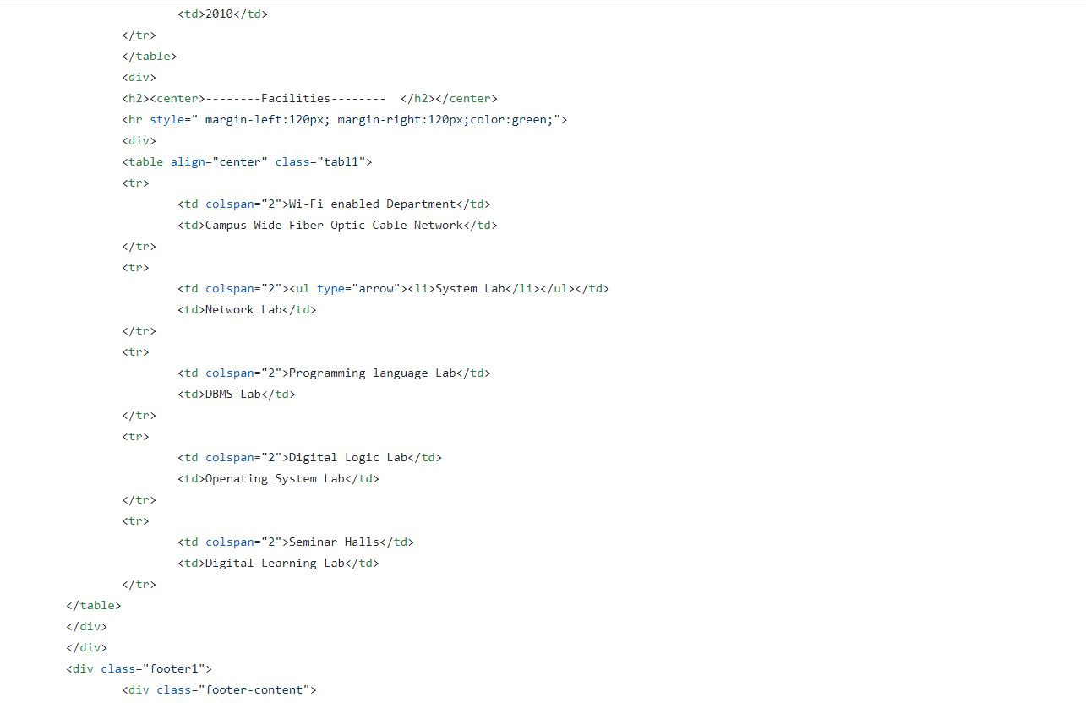

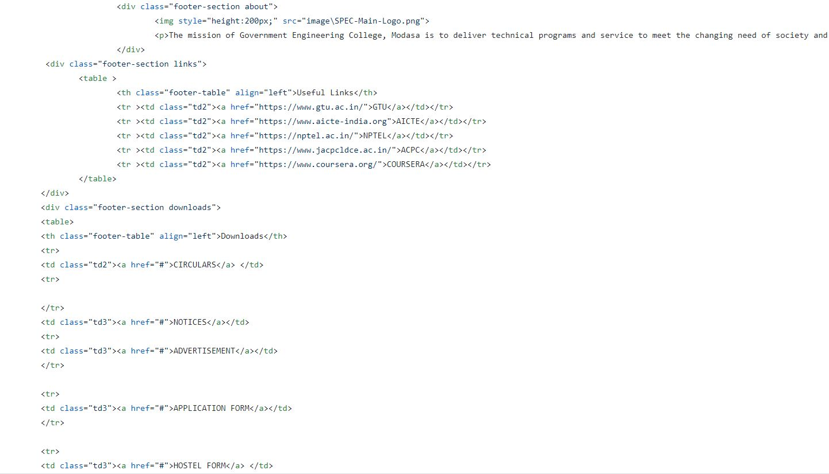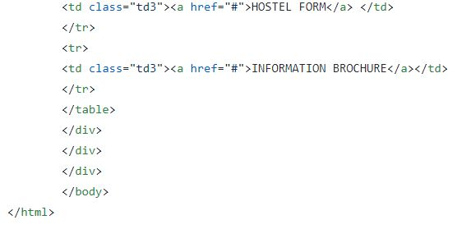

**Output**

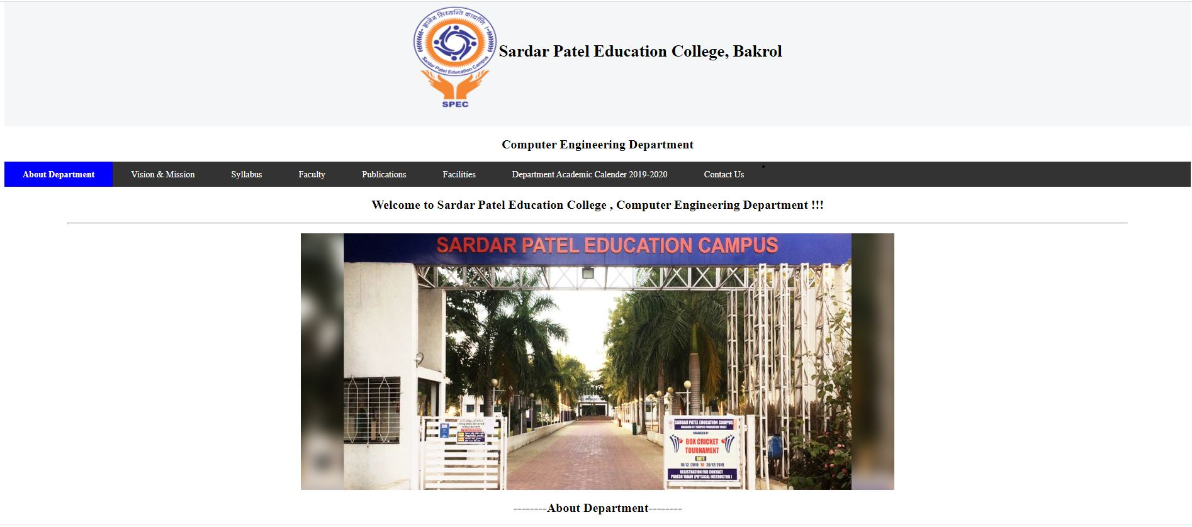

**4. Website Facilities**

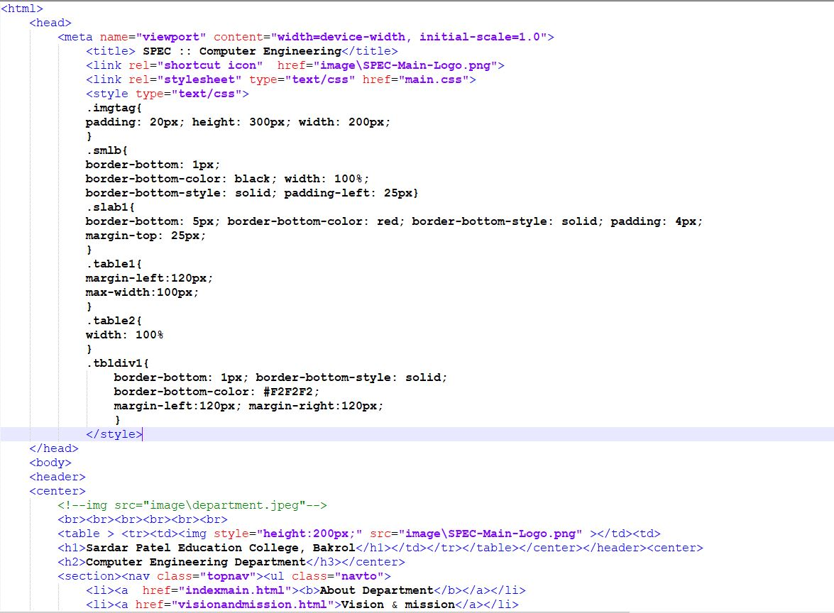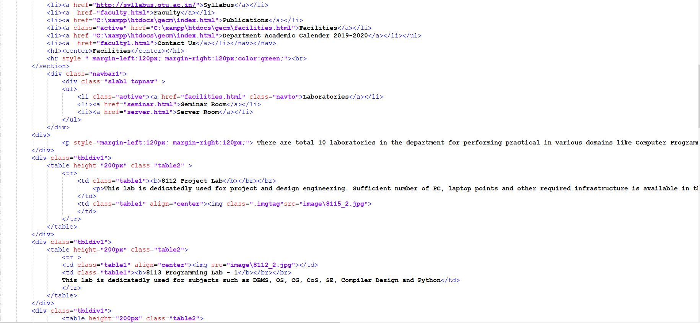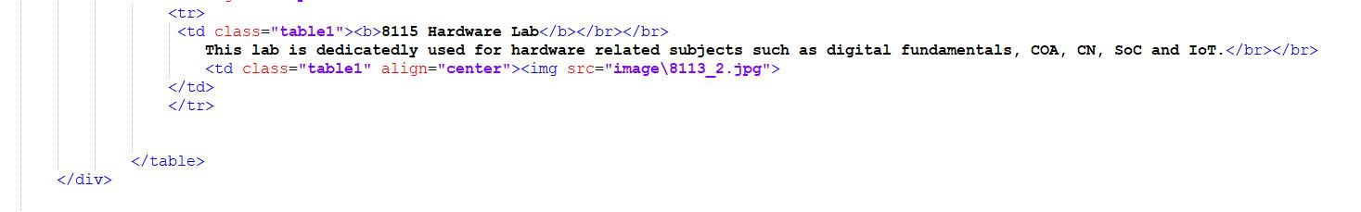

**Output**

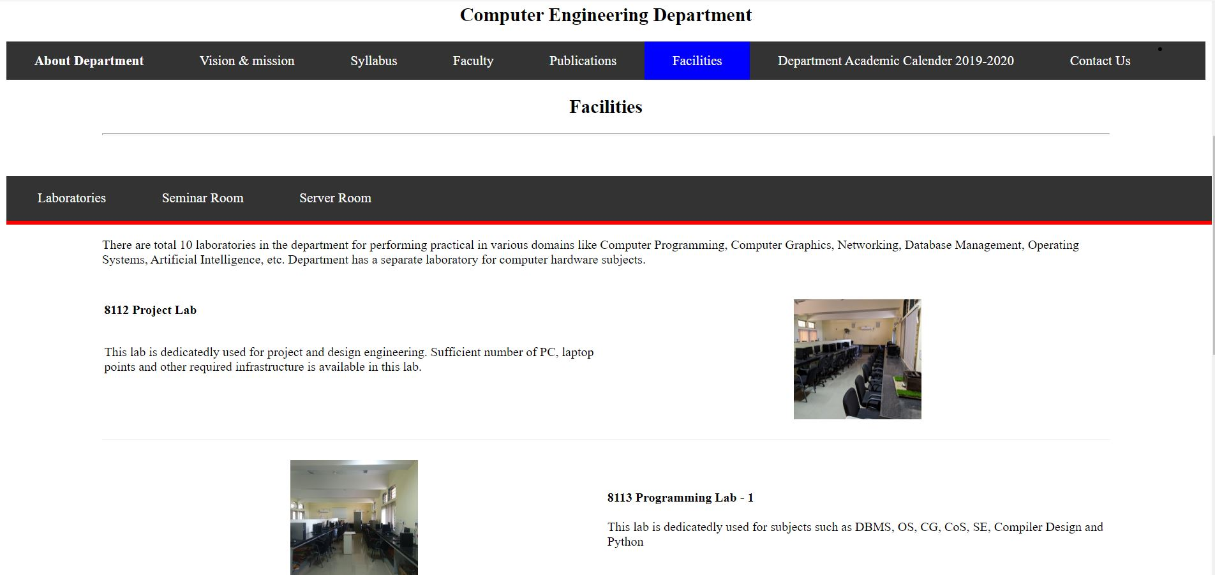

**5.Website Faculty:**

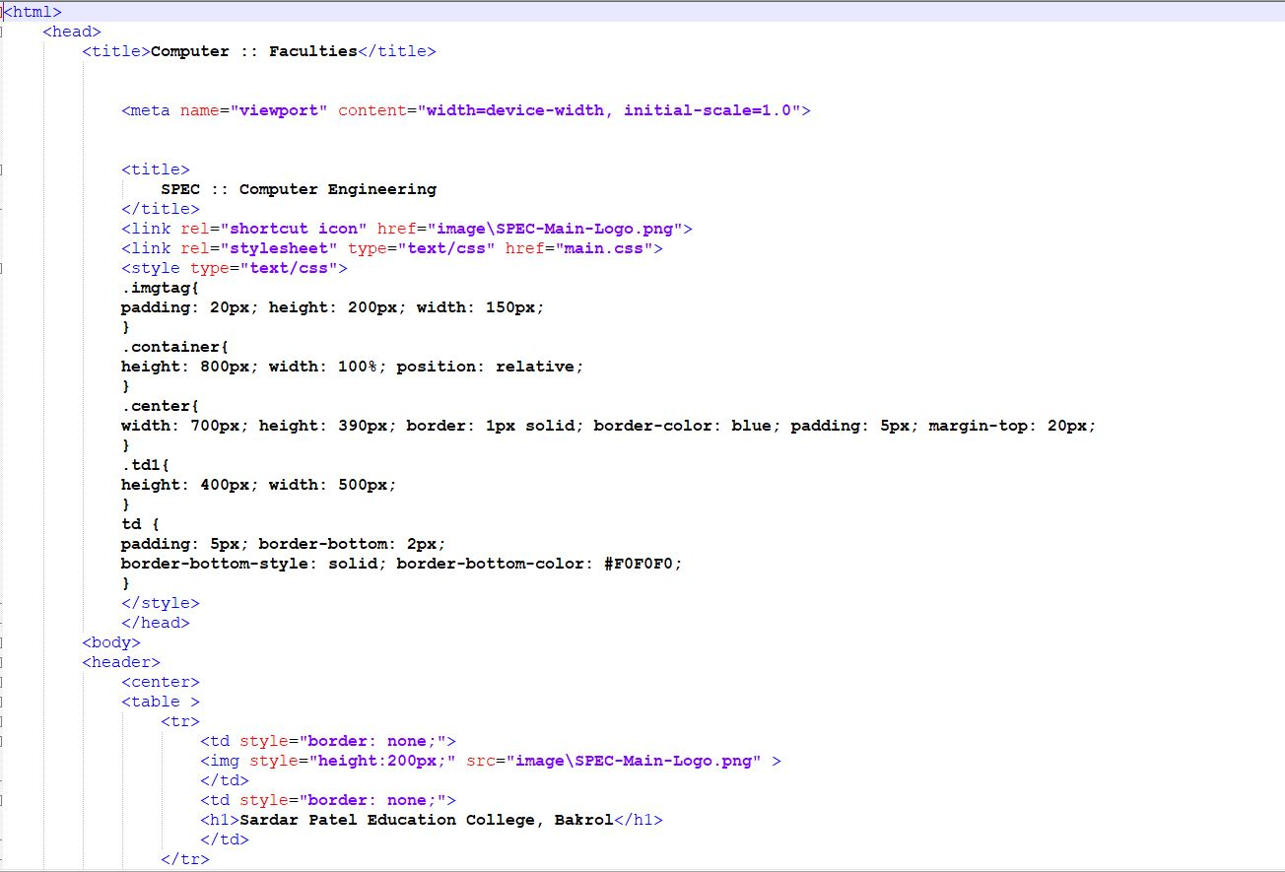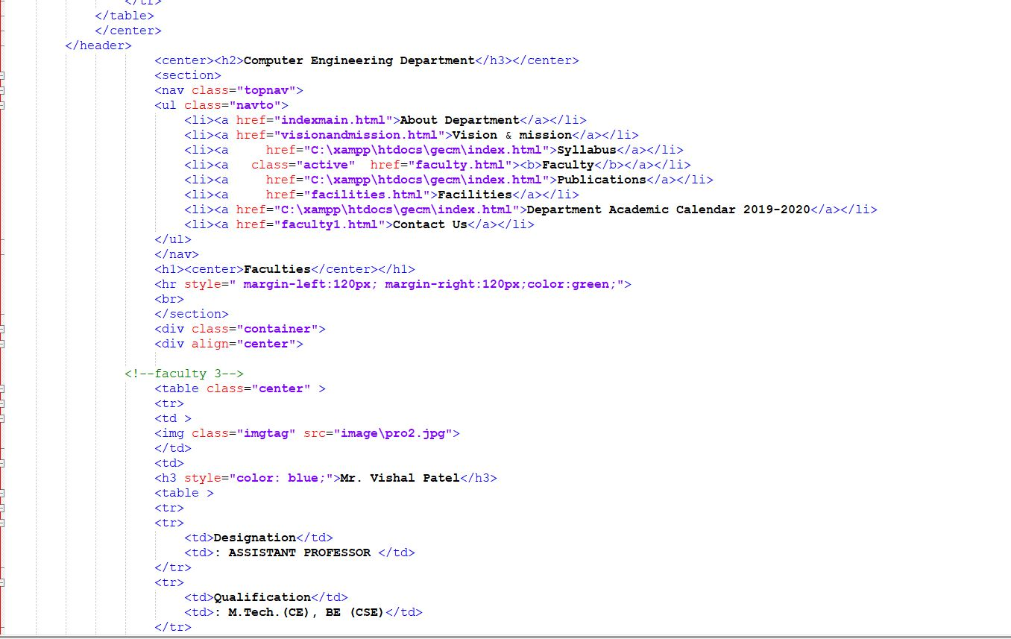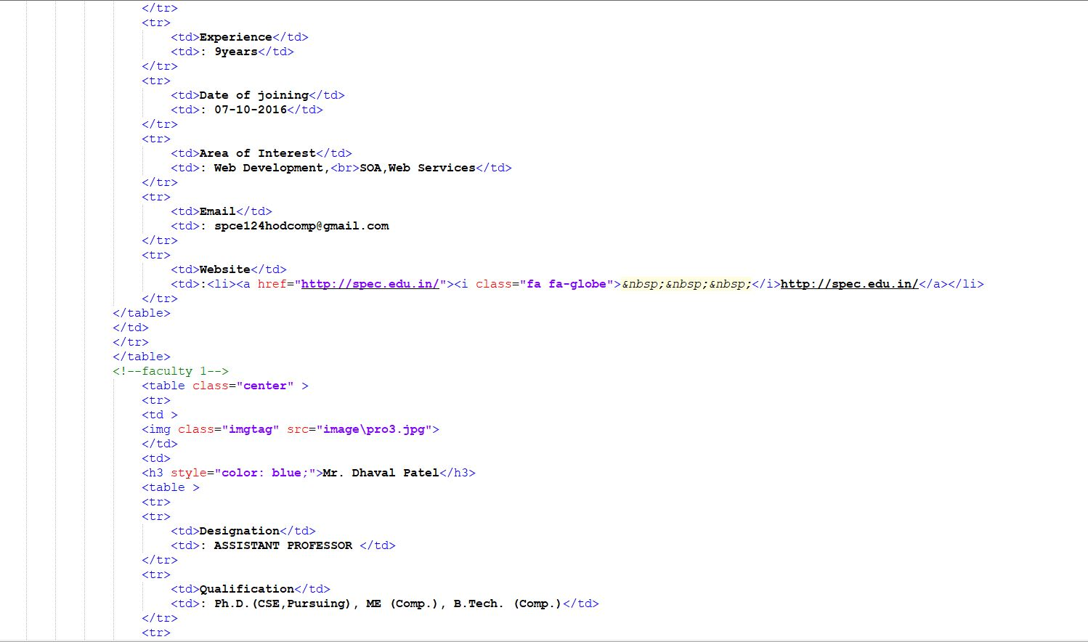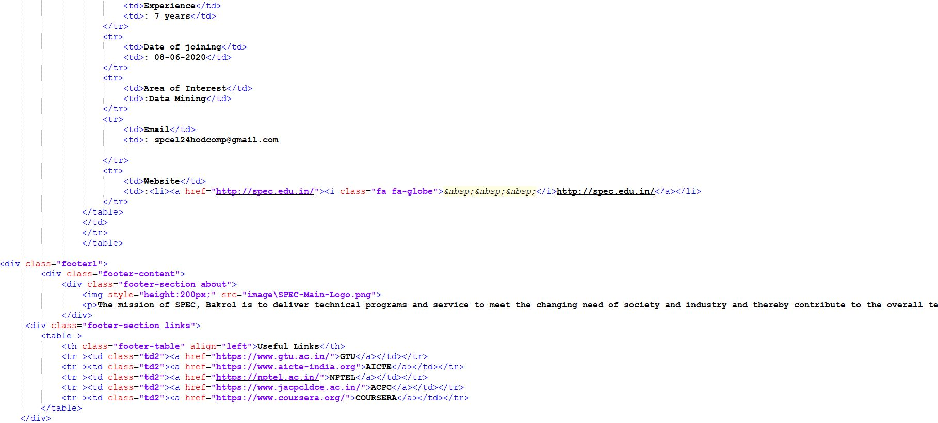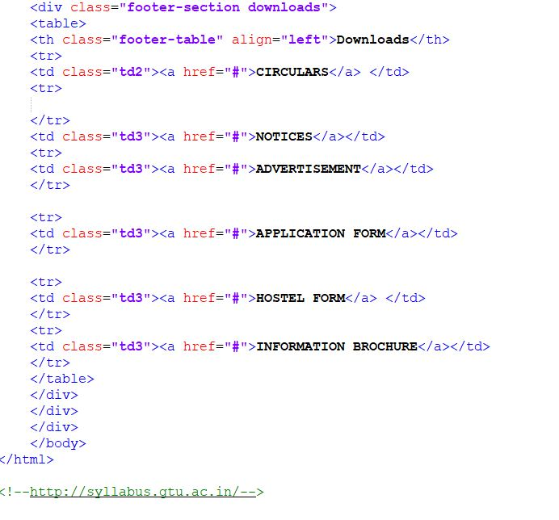

**Output**

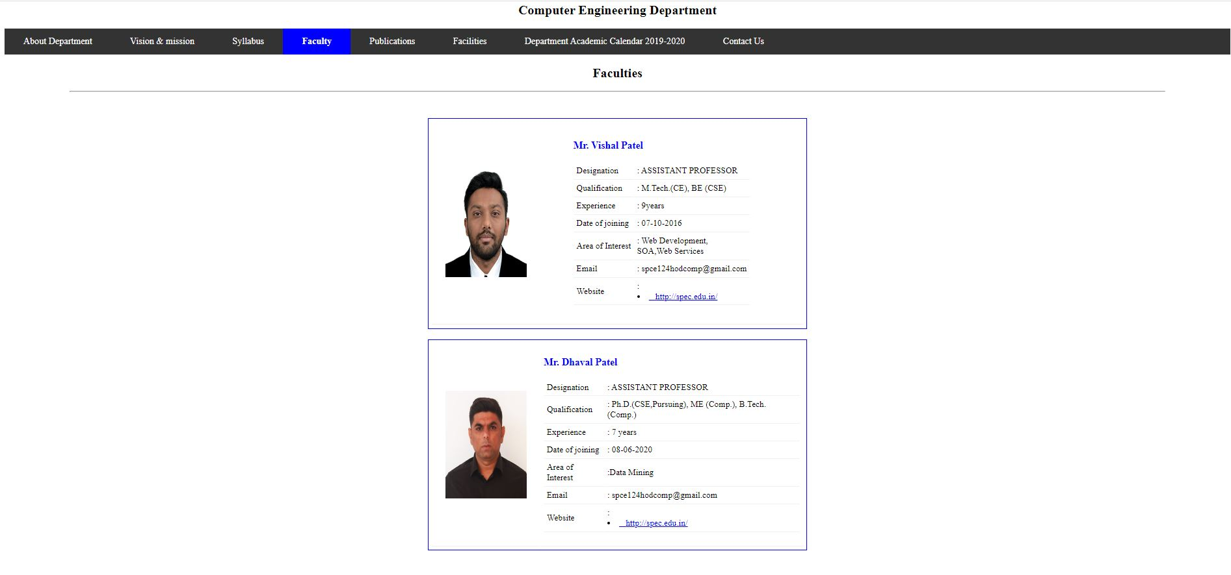

**6.Time Table**

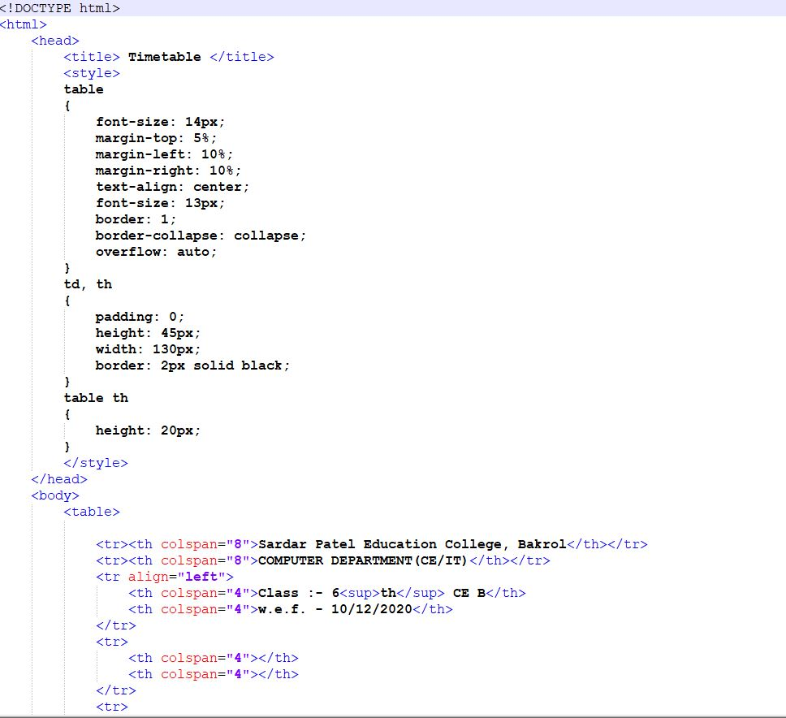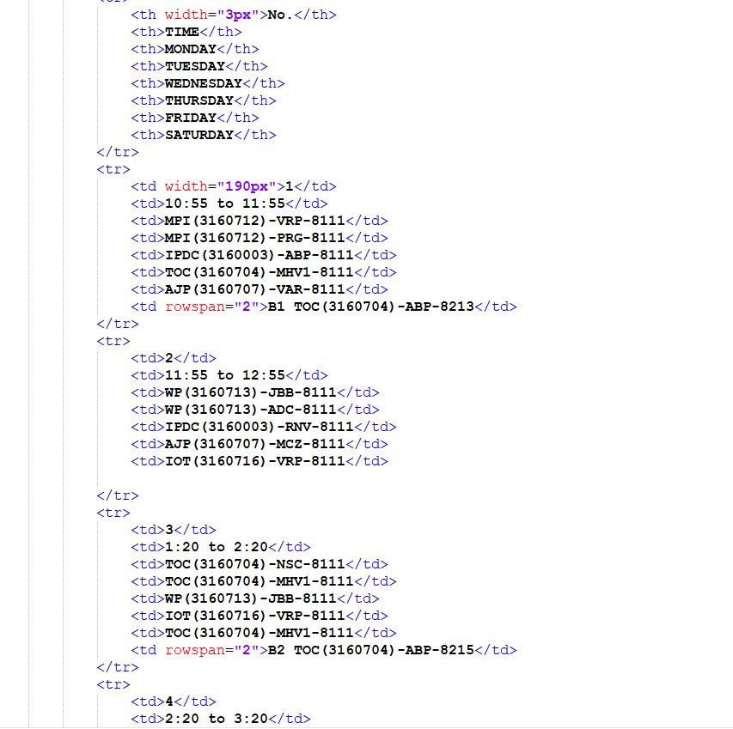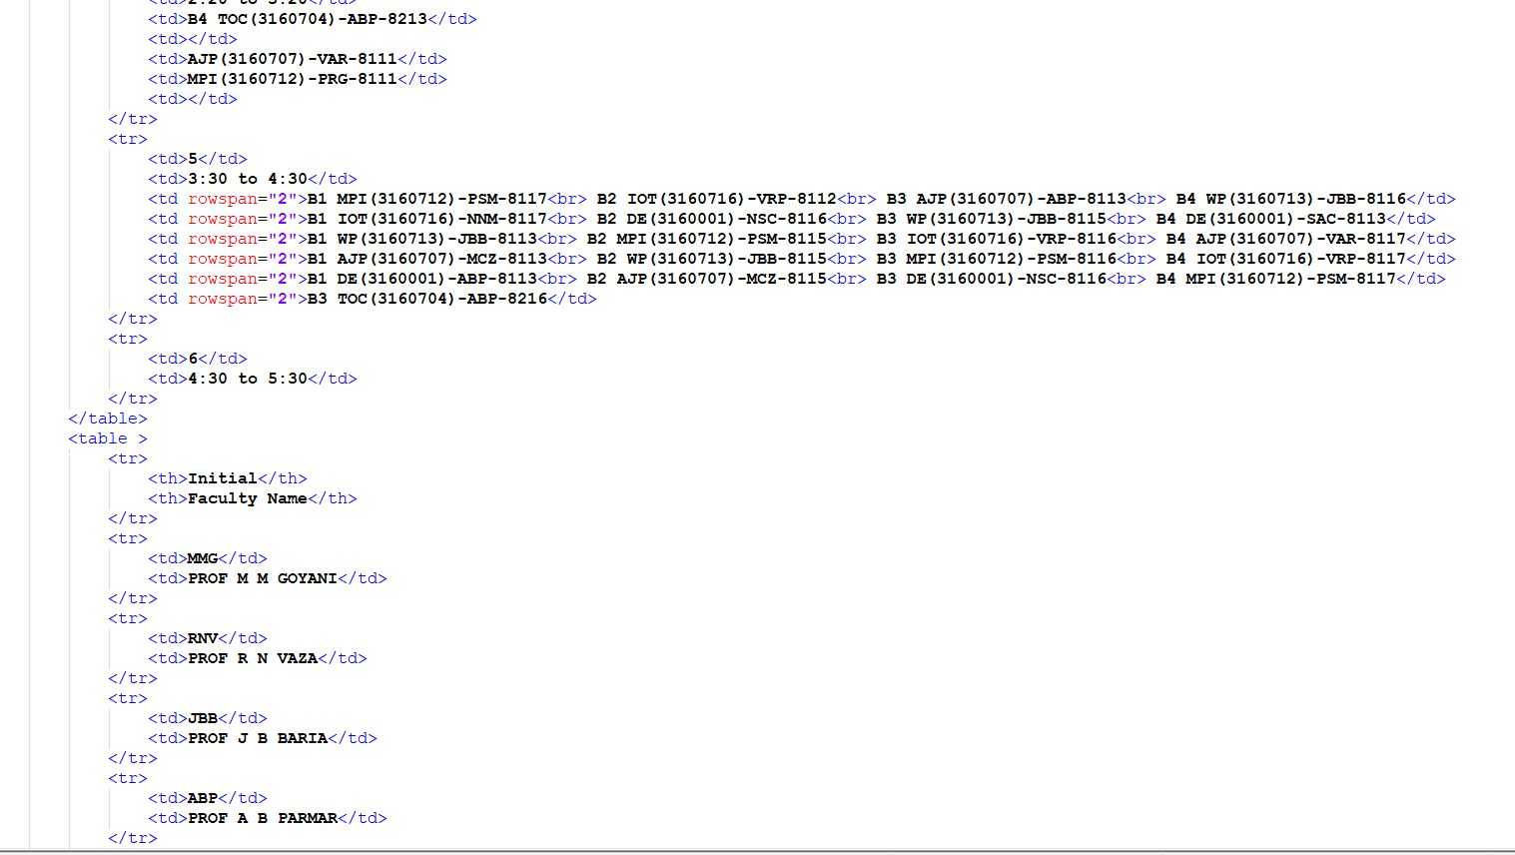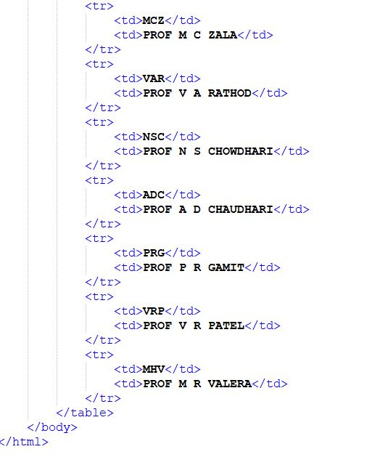

**Output**

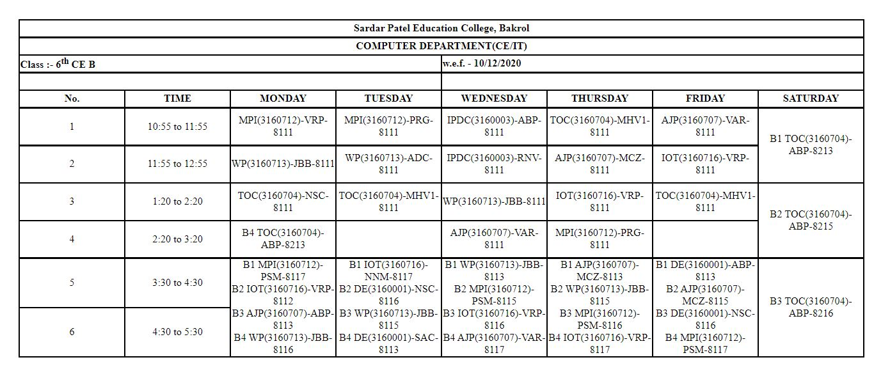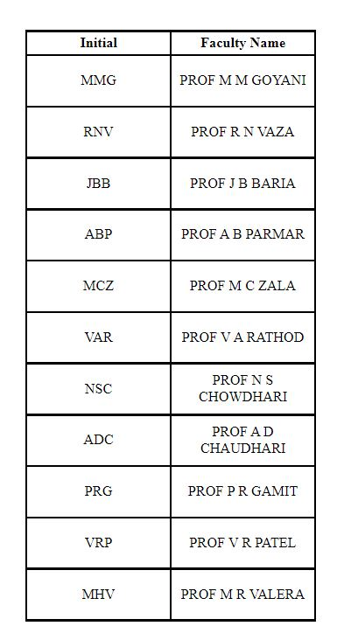

**7. Loop**

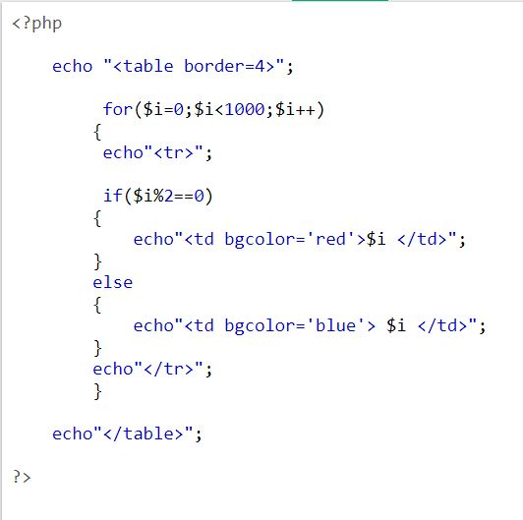

**Output**

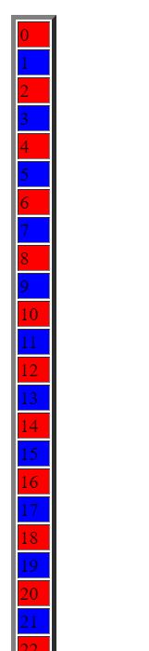

**8.Palindrome**

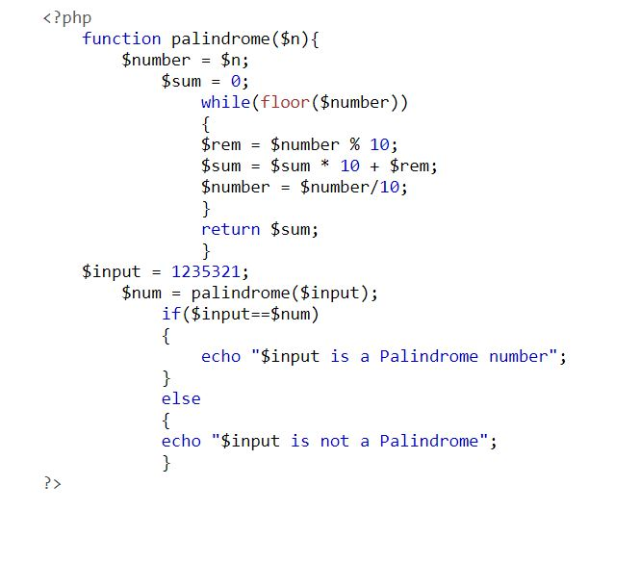

**Output**

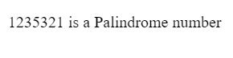

**9. MinMax**

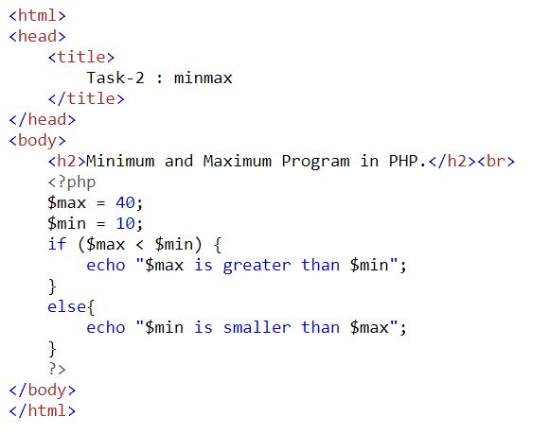

**Output**

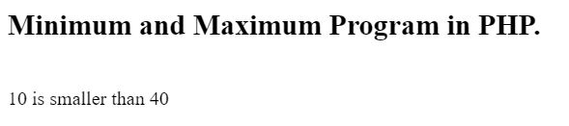

**10.GET/POST**

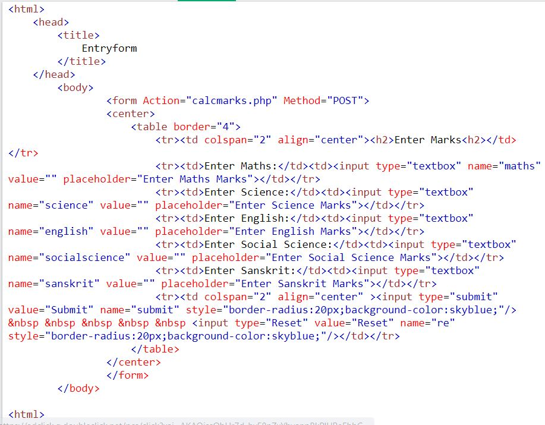

**Output**

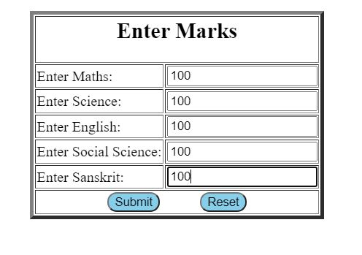

**11. Associative Array**

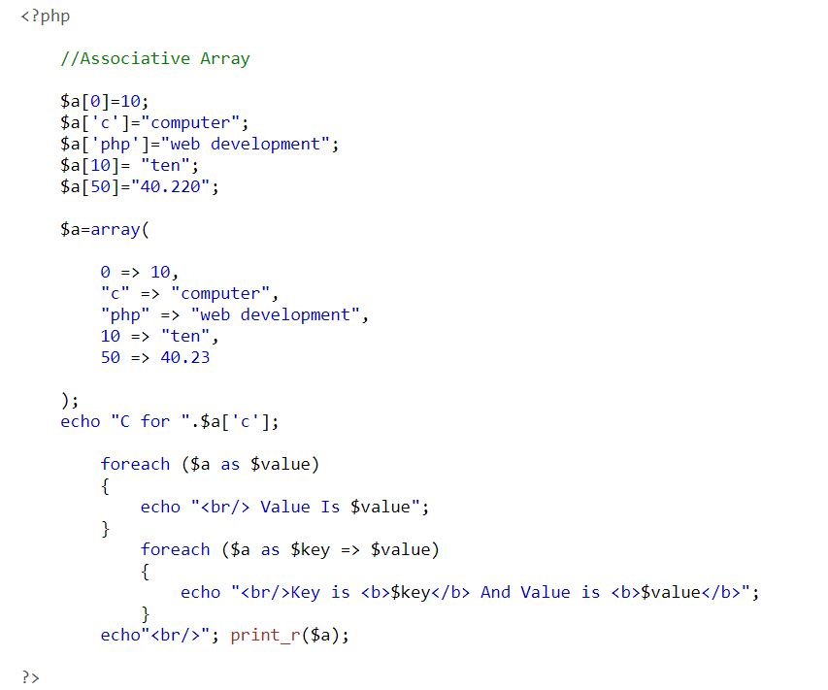

**Output**

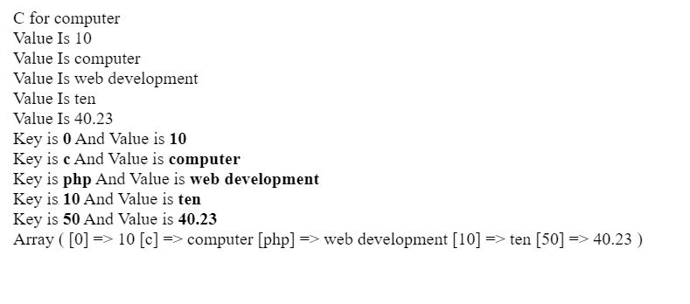

**12.Numeric Array**

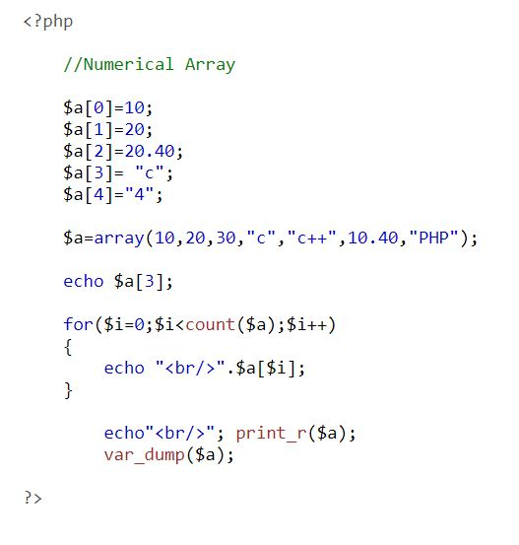

**Output**

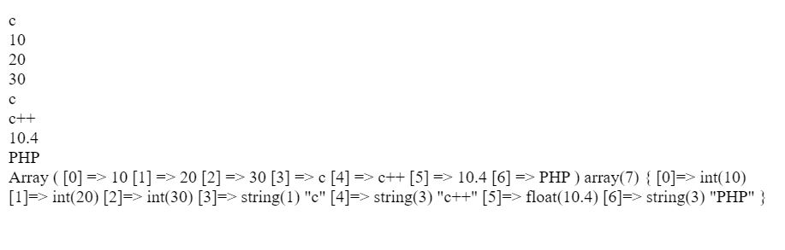

**13.Leap Year**

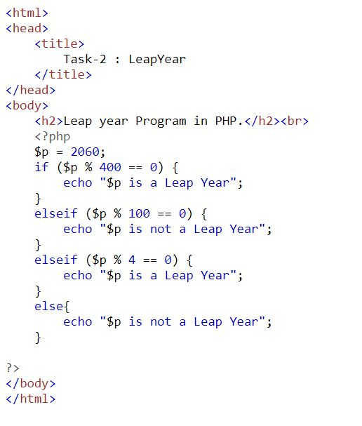

**Output**

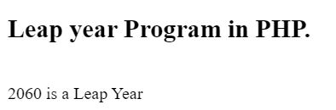

**14. Odd Even**

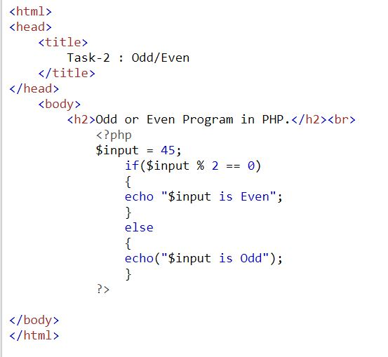

**Output**

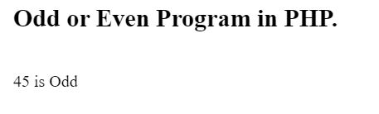

**15. Subtraction**

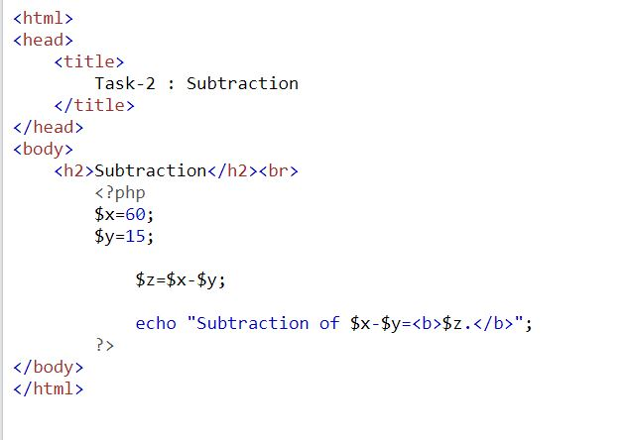

**Output**

